**Project on Employee Management System**

**Programming for Problem Solving**

**Department of Artificial Intelligence & Machine Learning**

**Thakur College of Engineering and Technology**

**Presented by: AIML-C (Batch-2)**

|  |  |  |
| --- | --- | --- |
| **Name of the Student:** | **Roll No:** | **Signature:** |
| SHAHI SHREYA PRAGATI SUNITA | **11** |  |
| SHAIKH AAYAN ALTAF AYASHA | **12** |  |
| SHAIKH MOHAMMED AYAN MOHAMMED HAFIZ MUMTAZBANO | **13** |  |
| SHAIKH MOHD SAAEM ZAKIR HUSSAIN REHANA | **14** |  |
| SHARMA AMANKUMAR ANIL JYOTI | **15** |  |
| SHETTY PAWAN NARAYAN POOJA | **16** |  |
| SHETTY RISHITH UMESH MAMASHREE | **17** |  |
| SHINDE ARYAN PRAKASH PADMA | **18** |  |
| SHINDE ROHIT SUDHIR SANJANA | **19** |  |
| SHUKLA ANMOL RAMESH SHWETA | **20** |  |

# **Introduction**

* **Objective:** The Employee Management System (EMS) is designed to efficiently handle employee records, attendance, and payroll management. Using SQL, it organizes employee data, allowing for streamlined data retrieval, updates, and analysis.
* **Features:**
  + Employee data management
  + Department classification
  + Payroll calculation based on attendance
  + Simplified CRUD (Create, Read, Update & Delete) operations

# **Algorithm**

Here’s a simplified algorithm for the EMS operations, focusing on CRUD actions in SQL.

1. **Initialize Database**
   * Create tables for Employee, Department, Payroll, and Attendance.
2. **Add Employee**
   * Input employee details.
   * Use INSERT SQL command to add the record.
3. **View Employee Information**
   * Use SELECT command to retrieve data with joins on Department.
4. **Update Employee Details**
   * Input Employee ID, updated details.
   * Use UPDATE command.
5. **Delete Employee Record**
   * Input Employee ID.
   * Use DELETE command.
6. **Mark Attendance**
   * Input Employee ID and date.
   * Use INSERT to store attendance status.
7. **Calculate Payroll**
   * Calculate salary based on attendance using SELECT and JOIN.
8. **End**

## **Flowchart**

# **Code**

## **4.1 Creating Tables**

1. **Department Table**

1. **Employee Table**

## **4.2 CRUD Operations**

1. **Insert Employee Record**



1. **Retrieve Employee with Department Name**

1. **Update Employee Salary**

1. **Delete Employee Record**

## **Payroll Calculation Based on Attendance**

## **Output**

1. **Complete Employee Record**

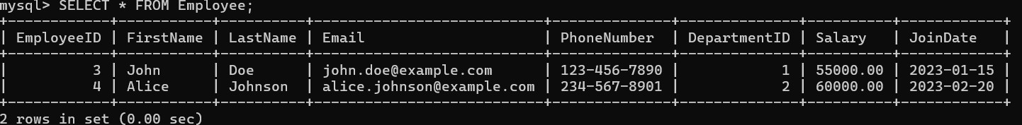

1. **Monthly Salary Calculation**

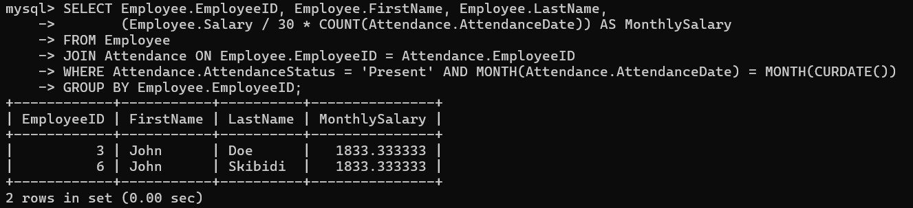

## **4.5. Conclusion**

The Employee Management System successfully demonstrates core SQL functions for handling employee records, attendance tracking, and payroll calculation. This project shows SQL’s capabilities for data integrity, efficient querying, and reporting, making it suitable for basic HR management in small to medium-sized organizations.

**Future Scope:** Expanding to support real-time analytics and adding integrations with external data visualization tools.

REFERENCES:

SQL Documentation: [MySQL Documentation](https://dev.mysql.com/doc/)

Database Design Patterns: [Database Design and SQL](https://database.guide/)

SQL Syntax: W3Schools SQL Tutorial